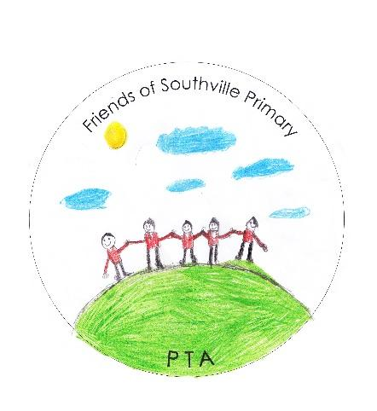
Southville Primary PTA Meeting Minutes
Tuesday 21st June 2022

In Attendance:
Helen Beach (Chair), Jess Swingler (Bears Rep), Liz Newton (Treasurer), Caroline Bennet-Clarke (Pelican/Honeybee Rep), Katherine Edwards (Teacher), Elspeth Steel (Vice Chair), Lucy Pook (1), Anna Clarke (Y5) Charlotte Todd (Y4), Jennifer Gibson (Governor / Y3) , Paula Mathias (Family Liaison Officer)

Apologies From:
Natalie Sanfilipo, (Y6), Alex Merchant (Y5) , Sonia Adams (Y1/Y3) , Mithi Shafiq (Y4), Tara Yapp (YR) , Lucy Stockall (Y1) , Kata Komar (Y5), Zara Rattrary (Y1)

Treasurers Report:

· Summer Fair made £6,877.53
· £24.42 has been receive from Easy Fundraising

Outgoings:

· £125 on Scrap Store Membership
· £750 towards year 6 leavers (£1500 in total)

We have ring fenced £3,523.31 (from previous pledges and now also including the money raised from an event in 2019 (!) which money was designated for the cooking room).

We have approximately £18500 in funds, which leaves us with approximately £15k for funding future enrichment.

We have now ordered 2 new cookers, restocked the whole kitchen for cooking club (food processor, pots, pans, spoons, trays). Spend- just over £1,000. This equipment will remain at KS2 Site.
Agreed to request for a non uniform day to fundraise for additional cooking equipment for KS1.
Helen to ask Andy.

Reviews:
- May Fair – Teachers really positive, really happy with the organisation

- Tea Towel Update – deadline to order is Sunday 26th. 95 orders so far. Sales to be promoted. Helen will ask the office to send a separate email/text to prompt people to buy them this week.

- Y6 Update – Krispy Kreme sale went really well – made just over £300. Didn’t sell out, it was too hot! But managed to sell the remainder at the school camp. Sold more at Myrtle. It worked well in that the Yr6’s were able to man the stall themselves. Feedback from the parent community has been taken into account for future reference. From these funds (and the beat the goalie at the May Fair) this will pay for their leavers party, including children who would not otherwise be able to attend. Every child is getting a leavers book and hoody.

- Sports Day - Ice pops and fruit to be given out by volunteers (all slots filled). Paula to discuss with Mr Commander with the PTA being a break station. There is a spare freezer at Merrywood now that can be filled up! Satsumas to be ordered from Ashton Fruit and they will deliver (cash on delivery).

- End of Year Treat: Usually there is about £1000 to spend on this (across both sites). Requests were Crazy Golf (hired in), skipping ropes, giant connect four. Katherine will find the company and organise it. If she can’t, will consider alternatives.

Requests from school:
- Dave (Site Manager) has asked for defibrillators (one for each site). Liz will talk to him about this- there is one located at Tesco by Myrtle and BS3 Community by Merrywood.
- Duolingo books for libraries - £10 per book (approx. £250) – KS1 and KS2. Fine to allocate some funds towards these. There was a vote and everyone was in favour.
Funding at £250 agreed.
- Arts & Crafts budget (per class). There is in fact some money already allocated and not spent on arts & crafts – £416. Need to check if it has been spent already.
- Growing fruit and veg – Helen thinks this falls under the OPAL project so need to check that
- Funding for Arts Trail (10/11th September). School wants to build a massive structure and need £4/500 for resources. Making flowers and creatures from natural products (but weather proof). Teacher’s are putting this together. Each class contributing something towards it. PTA paid for the stars last year. Need to know what the money is actually for – outline a proper quote.

Dates for 2022 Events:

- Welcome Picnic – Saturday 17th September. Previously the reception picnic has included pre-school.

- Halloween Discos – Noel pencilled in for 20th October – yr1/2 * yr3/4 * yr5/6 all on the same night, all at Myrtle

- Beginner’s Ball - 12th January at Merrywood, hosted by the PTA and volunteers (not all reception parents). However, it is important for parents as well to get to know each other. Can put a bar on for the parents. Charge for an adult ticket (£3)

- Christmas Cards – 1st November – Mithi wants someone to shadow her this year so they can take it on. Preferably a reception or year 1 parent. Could be a group effort.

- Comedy Night – Friday 11th November – Emma to work with comedians and PTA will organise bar etc. Each comedian needs to be paid. Don’t need to do anything for it yet other than organise the alcohol licence.

- Winter/Christmas Fayre – 3rd December. Maybe look at getting a SumUp machine. This will work much better than the QR code, especially at ‘bar’ events like games night/comedy nights etc. We could get hold the fayre at Myrtle (indoors) with trees outside in the playground

- Christmas Trees – to be sold at Christmas Fayre (3rd December). Happy to use the same place as last time. Their admin wasn’t very good but the trees were good quality. Not going to order trees in pots this year BUT we will over order so passers by can buy trees too.

- Christmas Crackers – happy to organise them again for this year. There are about 100 leftover from last year. To be pre-ordered in advance and collected at the fayre and then sell any remaining at the fayre

- Christmas Jumper Exchange – only 3 were donated last Christmas. Could maybe do a decorate your own jumper in class?

- New year – Games night/spring discos in the new year!

Lost Property Update:

- Maybe sell the second hand uniform or mention it at the new parent’s evening next week. Get the uniform from the Myrtle shed and take the small stuff – pay via donations
- There needs to be a different way of organising the lost property – there needs to be staff from each site that are sorting out the stuff. Otherwise, do it once per term except for the term before the summer fayre

Requests for Funding:
- Purchase our own candyfloss machine. Problem with having our own is that we will have to clean it/maintain it/store it. Renting costs £90 and to buy new it’s approx. £140/50 to buy one. Candyfloss makes such a huge profit, it would be great to wheel it out at every event! We can always sell it if it doesn’t work out. We will discuss further next time. Make sure it’s an industrial one (80 candyflosses an hour) so it might be a bit more expensive.

Date for next meeting:
- Thursday 15th September

