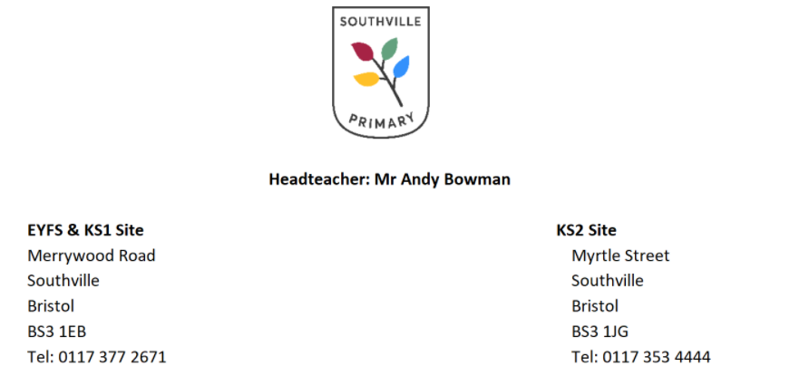
20.10.21
Dear Parents and Carers,
Before the summer holidays, we wrote to you to inform you that the Early Years Foundation Stage Curriculum would be changing in September 2021 as part of a national government reform. We have been really excited to look at these changes and implement them with a renewed focus on learning through play.
Learning Diaries
As we have previously communicated, the new framework gives guidance that is very clear about how practitioners work with our children in the early years. It is important that we spend the majority of our time engaging and interacting with the children and as a consequence we are unable to provide families with lots of videos and photographs to look at on a regular basis. Thank you for your support with the transition from nursery/prior settings to our reception class in light of this. We are working hard to set up our new systems and communication with our families is at the forefront of our minds when thinking about what the changes mean for our school.
As a starting point, we would like to introduce a new communication tool called Learning Journals. This online learning platform will replace Tapestry which we have used in previous years. Please could you fill in the consent form below which gives us permission to add your child to the system and return it to the Merrywood site school office.
To begin with, we will be inputting an entry point for your child which incorporates the views of parents, previous settings, school staff and the children themselves. We will be guided by milestones in learning that are age related and will inform you if your child has met them or has not yet met them. We will then provide ‘What next?’ possible lines of development for each child which you may also wish to follow up at home too.
In the meantime, whilst we get our new system up and running you can find out what we will be doing each term on our curriculum overview and letter, we send out weekly news on the school newsletter and you can find pictures of what the children across the school have been getting up to by following our school twitter account at: https://twitter.com/southville_prim
Thank you for your support and we look forward to seeing you soon for our parent/teacher meetings.
Kind Regards
Miss Jennifer Trimnell Early Years Foundation Stage Lead
Consent form regarding the access and usage of Learning Journals

Southville Primary School will be using Learning Journals to record observations, comments and videos to document your child’s learning and play in the Early Years Foundation Stage.
Please return this form as soon as possible to the school office. You will then be sent an email, to the nominated addresses below, with a link to the Learning Journals website with a secure login.
By signing below you are giving consent to the following terms and conditions:

Childs Name: ___________________________________________________
- I agree that Southville Primary School may create an online learning journal for my child on Learning Journals
- I agree not to share, screenshot or upload any information located on Learning Journals onto social media sites including notes, photographs and videos.
- I agree to my child appearing in group observations encompassing notes, photographs and videos that may be included in other children’s learning diaries
- I agree to keep my login details safe
- I agree that I will access Learning Journals for personal use only
Signed:

Name:

Date:
If you do not agree with any of the above statements please put a line through the statement and we will contact you to discuss the steps that we will take to adhere to your wishes.

Please confirm your email address/es:
1: Name: _______________________________________________________________
Relationship to Child: ___________________________________________________
Email Address: _______________________________________________________
Signature: ____________________________________________________________

2: Name: _______________________________________________________________
Relationship to Child: ___________________________________________________
Email Address: _______________________________________________________
Signature: ____________________________________________________________

